***DESIGN AN AUTOMATED NIGHT LIGHTING SYSTEM***

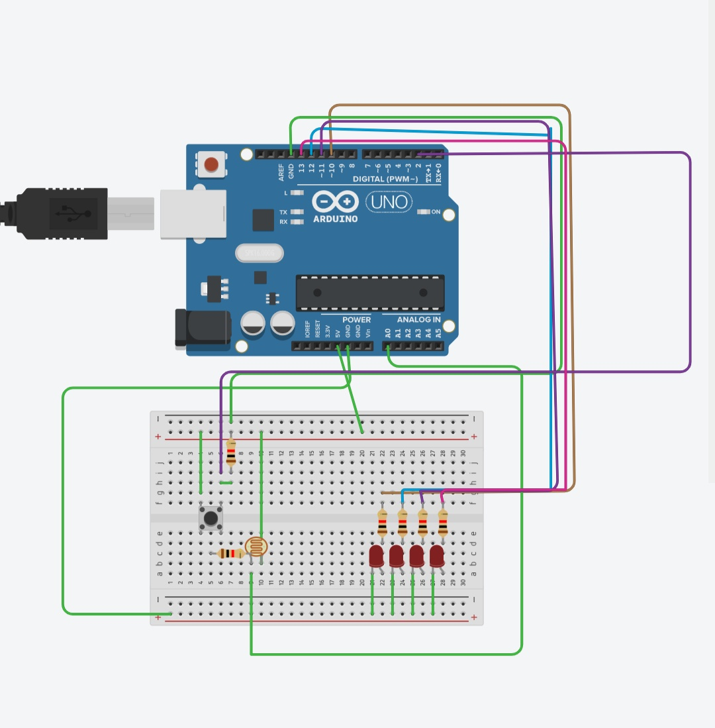

***CONCEPT USED:***

***For making this circuit we used Arduino, led , resistors, wires, LDR and push buttons.***

***LEARNING OUTCOMES:***

***With the help of wire we connected the various components used in lighting to Arduino so that our circuit will work properly.***

***We have to connect the wires properly otherwise it will not work.***

***PROBLEMS AND TROUBLESHOOTING:***

***Due to inappropriate connections circuit may gets damage or led can get damaged.***

***So we have to be sure about the connections and how to fix wires and at which place.***

***If the connection is wrong then our circuit will not work.***

***PRECAUTIONS:***

***Check the led before doing the connections.***

***If the connection is wrong then circuit will not work.***